**CHAPTER 3**

**CAN I DECODE THE BARS**

**3.1 Observe The Bars**

So let's say you would like to decode the actual bars in the bar code and map them to numbers. This is something that will make you cross-eyed, but it can be done.

First of all, look at any 12-digit bar code. It is made up of black bars and white spaces between the bars. Assume that the thinnest bar or space that you see.

**3.2 Technique**

(The first bar on the left) can be called "one unit wide." , This one unit width is used for further computation, The bars and spaces can therefore be seen to have proportional widths of one, two, three or four units, Mean’s that taking first as unit bar and it’s length as unit, now we can compute the length of preceding bars and divide it on the unit,

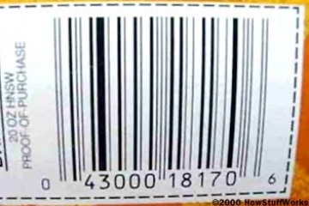That If you look at any bar code you can see examples of these four widths.

The start of any bar code is "1-1-1." That is, starting at the left you find a one-unit-wide black bar followed by a one-unit-wide white space followed by a one-unit-wide black bar (bar-space-bar). Following the start code, the digits are encoded like this:

Start MID Stop

C:\Users\ICUP\Desktop\sta.jpgC:\Users\ICUP\Desktop\sta.jpgC:\Users\ICUP\Desktop\mid.jpg

The Start, Stop, Mid bars are very important using them a barcode scanner can identify the barcode from the image, Without using them barcode cannot be identified from the image.

For fast computation these bar’s must, other wise no computation will be performed.

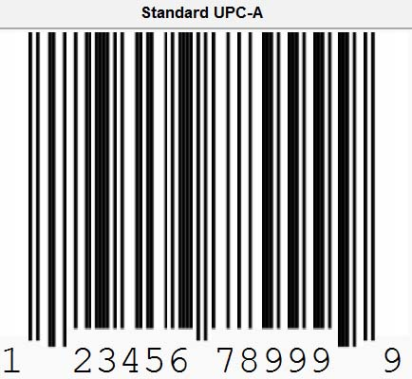.

**3.3 Barcode Representing Table:**

|  |  |  |
| --- | --- | --- |
| **Number** | **(Space-bar-space-bar)**  **Left Side** | **(Bar-space-bar-Space)**  **Right Side** |
| 0 | 3-2-1-1 | 3-2-1-1 |
| 1 | 2-2-2-1 | 2-2-2-1 |
| 2 | 2-1-2-2 | 2-1-2-2 |
| 3 | 1-4-1-1 | 1-4-1-1 |
| 4 | 1-1-3-2 | 1-1-3-2 |
| 5 | 1-2-3-1 | 1-2-3-1 |
| 6 | 1-1-1-4 | 1-1-1-4 |
| 7 | 1-3-1-2 | 1-3-1-2 |
| 8 | 1-2-1-3 | 1-2-1-3 |
| 9 | 3-1-1-2 | 3-1-1-2 |

Here we are interested in both white and black bar’s, we will maintain the record of all of them, if we represent a digit it takes (Unit *7 ) Space in the image, If we see the table above for barcode construction, we conclude that a single disgit is represented by 7 unit space and adding them we got 7.

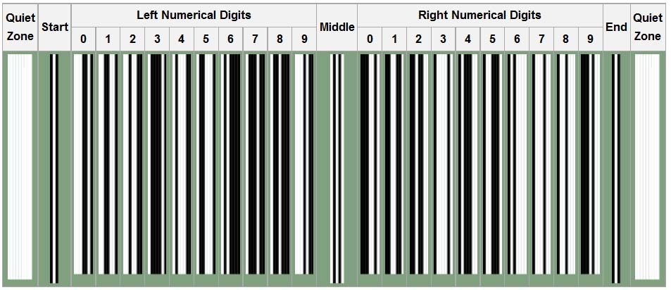**3.4 Encoding Information :**

The above bar’s information is also represented in the table, we graphically represented it above for the assistance.

We can clearly see that left numerical Digit information representation is quiet opposite of the right digits representation in bar’s.

**3.5 Points to be Noted:**

All of these encodings seem to add up to 7.

When we are making or decoding a UPC bar code, there 12 digits long information can be stored and after reading the first ‘6’ digits, the last ‘6’ digit information stored in reverse bar order. The white become black and black become white.

More clear that when we read first 6 digits the order of bars is (White-Black- White-Black), and for last 6 digits the order is(Black- White-Black-White).

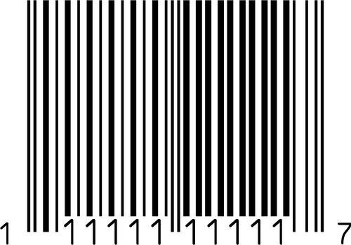

**3.6 Example:**

Now if we want to encode an image the following steps will be followed, these steps are performed by the computers, but for human understanding they are mentioned below.

The code embedded in the bars is **043000181706**

* The bar code starts with the standard start code of 1-1-1 (bar-space-bar).
* The zero is 3-2-1-1 (space-bar-space-bar).
* The four is 1-1-3-2 (space-bar-space-bar).
* The three is 1-4-1-1 (space-bar-space-bar).
* The next three zeros are 3-2-1-1 (space-bar-space-bar).
* In the middle there is a standard 1-1-1-1-1 (space-bar-space-bar-space), which is important because it means the numbers on the right are optically inverted!
* The one is 2-2-2-1 (bar-space-bar-space).
* The eight is 1-2-1-3 (bar-space-bar-space).
* The one is 2-2-2-1 (bar-space-bar-space).
* The seven is 1-3-1-2 (bar-space-bar-space).
* The zero is 3-2-1-1 (bar-space-bar-space).
* The six is 1-1-1-4 (bar-space-bar-space).
* The stop character is a 1-1-1 (bar-space-bar).

